-UV UNWRAPPING NOTES-

<https://www.youtube.com/watch?v=BbZ7ip-eCcI>

* Why do we need to unwrap?
  + Allows us to apply textures to our low poly model
  + Allows us to bake down our high poly information to apply it to our low poly model
* **Essential Rules of Unwrapping**
  + You need to be sure how much you want on a single texture before you start
    - E.g. a weapon with a scope – the scope would have it’s own texture sheet so that it could be used for other weapons and it’s texture would only be loaded in when required
  + It is important to decide your texture resolution
    - Typically speaking, a first-person shooter would use 2k maps for weapons
  + It is important to maximise the use of UV space to ensure that the texture has the maximum available resolution when we save it later on
  + Avoid hard edges in your UV islands as it typically results in stretching of your textures and, in particular, distorts the normal map for your object
    - Just try to go with the flow for your model
  + While you can unwrap rings as a planar map, it would cause your normal map to have a lot of “zig-zagging” so it is far more beneficial to lay them out as strips

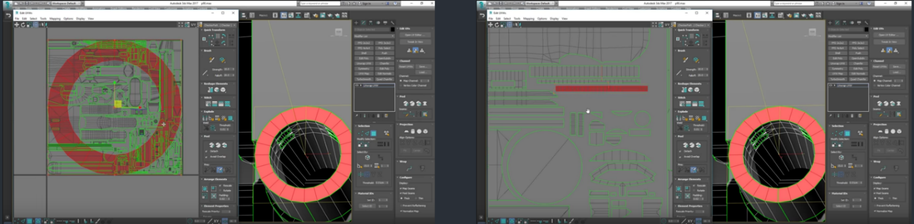  
Before and After Unwrapping a Ring

* + Try to ensure that everything is as straight as it can be on your UV borders
    - Make use of edge and align tools to accomplish this
    - In some cases, this can come with the price of a slight amount of distortion, but will make it far easier to texture and will look better for normal maps
  + Avoid zig-zagging and distortion as much as possible
  + Follow the flow of the model for the UV borders and avoid adding hard edges to your UV islands
  + Apply one smoothing group to each UV island for the perfect normal map bake
    - TexTools > Tools > Apply smoothing groups from UV shells
* **Full Demonstration of Unwrapping – Tips and Tricks**
  + <https://drive.google.com/drive/folders/0B0rKo4v9JhvgTElrSnR4eGYyMjA> All Free Assets from ChamferZone
  + Use Shift + S for ‘smartstitch’ script
    - For this to work properly, ensure your settings under Tools > Stitch Selected are as follows
    - 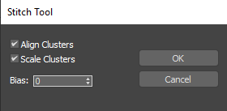
  + To get a good base for your Unwrap, you can start by using ‘Flatten by smoothing group’ as it will help speed up the process
    - If you don’t have any smoothing groups in place, you can make use of the ‘Autosmooth’ tool to get started
    - 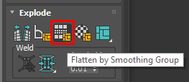
    - Although this provides a good basis for our unwrap, it can cause stretching and distortion issues since it does not relax the UV islands as seen below

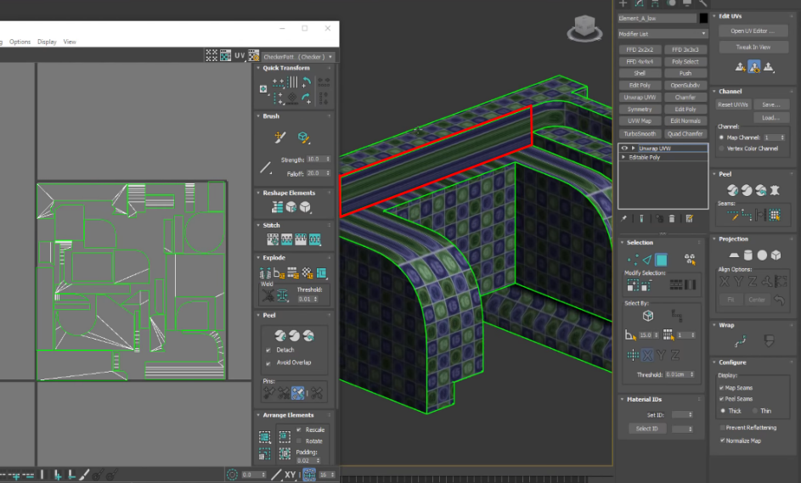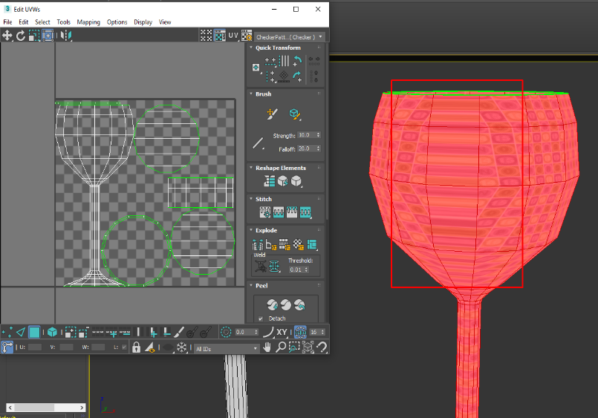

* + - To rectify this, make use of the ‘Peel Mode’ tool to relax your UV islands
      * Peel mode is similar to the relax tool, except that it causes less issues in terms of distorting UV islands
    - If there are some distortions in your UV islands, you can use the ‘Quick Planar’ tool to rectify UV island
      * This will cause differentiation in texture resolution, but this can be fixed by using the ‘Rescale Elements’ button
    - Flatten Mapping sometimes adds seams in unusual places, particularly along strips for cylinders/curves
      * This can easily be rectified using smart stitch
    - **Select an edge > convert edge selection to seam - unfolds along the seam to give a perfect strip** 
      * **Quick planar > peel > select an edge > convert edge selection to seam**

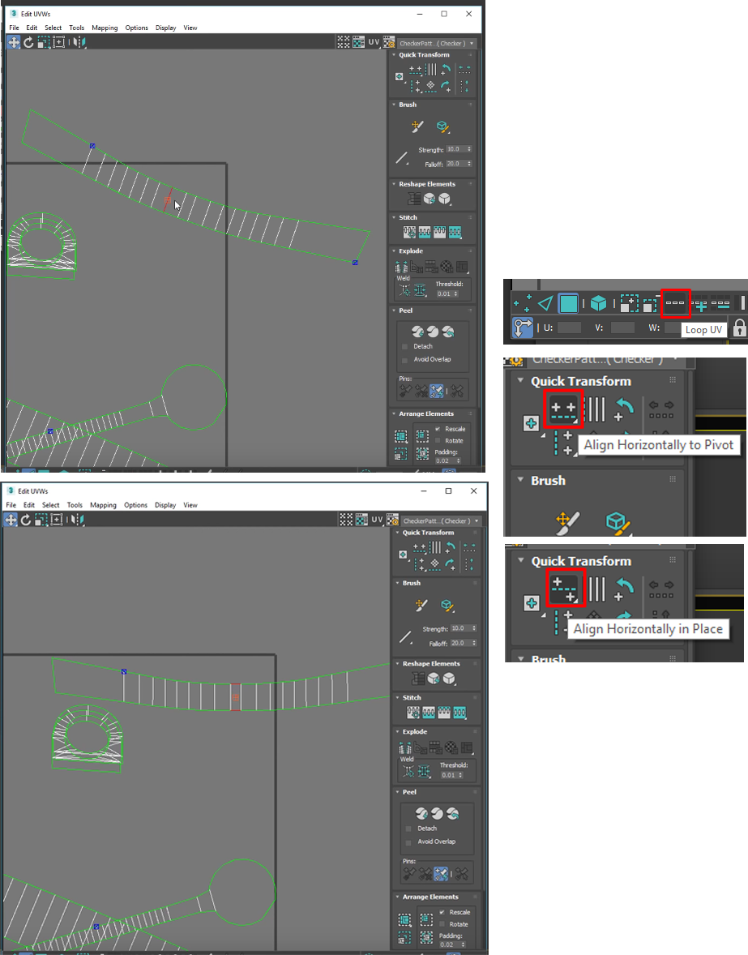  
For UV Islands with some curvature, you should start my aligning the middle edges to the UV border as shown. Then, with the two middle edges selected, use the 'Loop UV' tool to select the top and bottom set of objects. By clicking and holding the 'Align Horizontally to Pivot' button, we can bring up a different option. Use the 'Align Horizontally in Place' tool to straighten out the top and bottom set of edges.

Similarly, you can straighten the vertical edges by selecting one of the outer vertical edges and using a Ring select as shown. By clicking and holding the 'Align Vertictally to Pivot' button, we can bring up an option to align vertically in place, which we can use to straighten the vertical edges of our UV island.

* 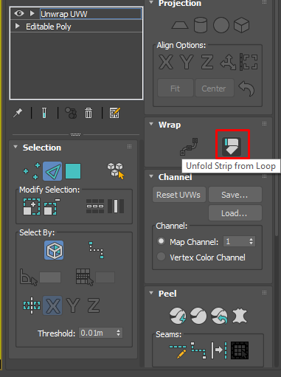For cylindrical objects, you can select one of the edges and use the ‘Unfold Strip from Loop’ object to flatten the cylinder into a rectangular strip
* **Method**
  + Make use of flatten mapping and quick planar/projection mapping to map certain areas, using smart stitch where necessary
  + When all areas are mapped, use peel mode to ensure every UV island is relaxed
    - If using the peel mode stacks everything in a messy way, make use of ‘Pack Custom’ to make everything neat
  + Then make use of the edge and align tools to make sure everything is straight with the UV borders to avoid zigzagging in your normal map
  + Rescale elements to ensure everything has the same texel density
  + Lastly, use the ‘Pack Normalise’ tool with ‘rescale’ unchecked (0.01 padding) to pack all the UVs into the 0-1 boundary
  + Before exporting > TexTools > Tools > Smoothing Groups from UV shells
  + In the case where you **definitely** will not see the face of an object, the individual faces can be scaled down before using the pack tool again. This will ultimately allow the UV islands for the important faces to be much bigger
* **N.B. If you need multiple objects to share the same texel density**
  + **Select all objects > Utilities panel (Spanner icon) > Collapse > Collapse Selected > UVW Unwrap > Select All > Rescale Elements > then separate elements and pack normalise UVs with rescale unchecked**